Date: 07-02-2022. Location: Shri Kumareshwar College of Education Hangal.
Event: Valedictory function of final year B.Ed. trainees.
Attendees: President of the function Dr. Sadashivappa.N.
All the teaching and non teaching staff members of the college.
And all the B.Ed. trainees.
The program was well began with prayer song by Aishwarya.
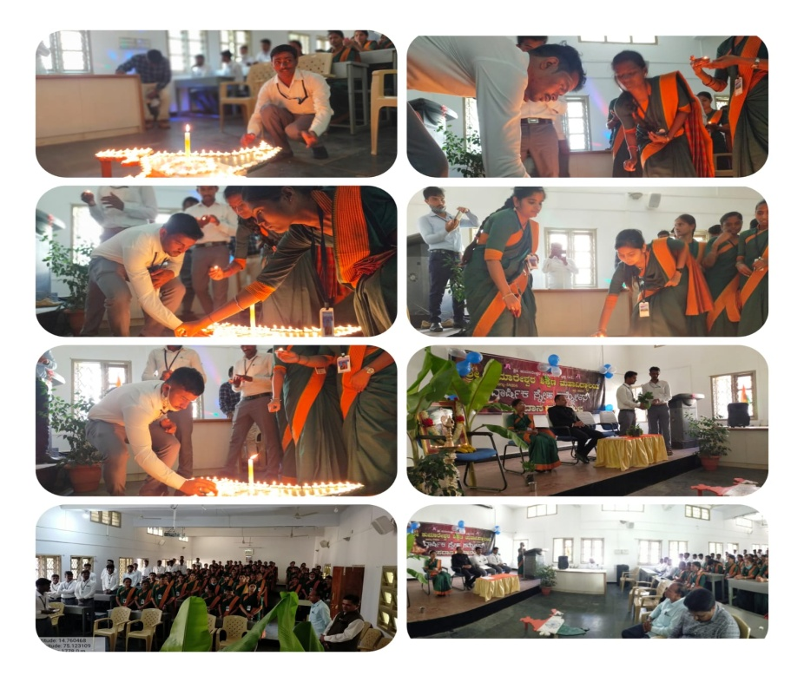
Dr Vishwanath Bondade sir, gave the welcome speech to the President of the function, teaching and non teaching staff and all those who were present in the function .Then, sir gave the review of whole journey of B.Ed. course completed by the students all the important occasions of B.Ed. was reviewed during this time then one of the B.Ed. trainee Guthema shared her experience regarding the completion of B.Ed. course through her wonderful poetry. After this President of the function Dr. Sadashivappa. N sir was requested to give the oath taking program all the trainees took the oath that they will be sincere to the noble profession of teaching till their last breath and provide justice to the students. Oath taking program, headed by Dr
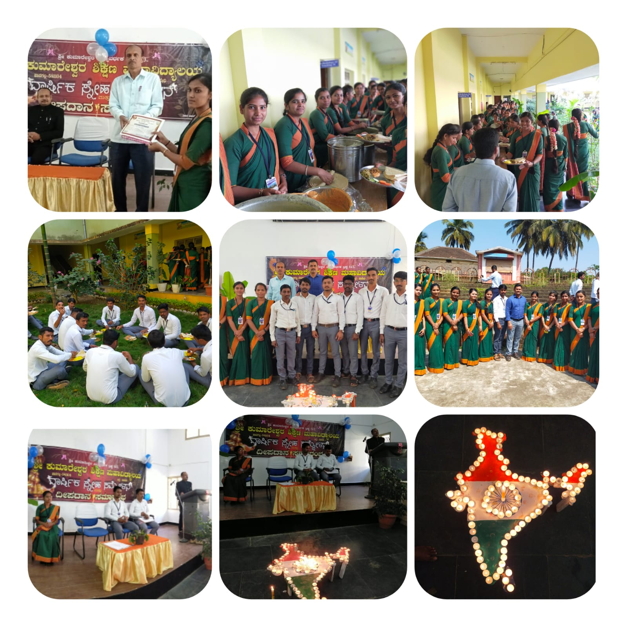
Dr. Sadashivappa.N sir President of the function jnana Jyoti was then enlightened with all the teaching and non teaching staff and B.Ed trainees. Further, our beloved Principal gave the President talk and Dr Vishwanath Bondade sir gave the vote of thanks. Lastly the program was concluded by taking the group photo.

